Producer-Consumer Problem
Definition
The Producer-Consumer Problem (also called Bounded-Buffer Problem) involves two types of processes sharing a fixed-size buffer. Producers generate data and put it into the buffer, while consumers take data from the buffer.
Key Challenges
- Producer must not add data to a full buffer
- Consumer must not remove data from an empty buffer
- Access to buffer must be mutually exclusive
Visual Representation
text
Producer(s) → [ BUFFER ] → Consumer(s)
Fixed Size
Put data Remove data

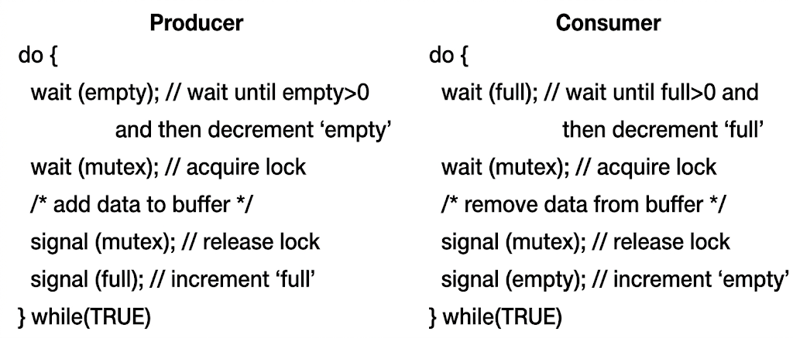
Simple C Code Example
c
#include <stdio.h>
#include <pthread.h>
#include <semaphore.h>

#define BUFFER_SIZE 5
#define NUM_ITEMS 10

int buffer[BUFFER_SIZE];
int count = 0; // Items in buffer
int in = 0; // Next free position
int out = 0; // Next full position

sem_t empty; // Counts empty slots
sem_t full; // Counts full slots
pthread_mutex_t mutex; // Protects buffer access

void* producer(void* arg) {
for(int i = 0; i < NUM_ITEMS; i++) {
// Wait for empty slot
sem_wait(&empty);

// Lock buffer
pthread_mutex_lock(&mutex);

// CRITICAL SECTION: Add item
buffer[in] = i;
printf("Produced: %d at position %d\n", i, in);
in = (in + 1) % BUFFER_SIZE;
count++;

// Unlock buffer
pthread_mutex_unlock(&mutex);

// Signal that buffer has data
sem_post(&full);
}
return NULL;
}

void* consumer(void* arg) {
for(int i = 0; i < NUM_ITEMS; i++) {
// Wait for full slot
sem_wait(&full);

// Lock buffer
pthread_mutex_lock(&mutex);

// CRITICAL SECTION: Remove item
int item = buffer[out];
printf("Consumed: %d from position %d\n", item, out);
out = (out + 1) % BUFFER_SIZE;
count--;

// Unlock buffer
pthread_mutex_unlock(&mutex);

// Signal that buffer has empty slot
sem_post(&empty);
}
return NULL;
}

int main() {
pthread_t prod, cons;

sem_init(&empty, 0, BUFFER_SIZE); // Initially all slots empty
sem_init(&full, 0, 0); // Initially no slots full
pthread_mutex_init(&mutex, NULL);

pthread_create(&prod, NULL, producer, NULL);
pthread_create(&cons, NULL, consumer, NULL);

pthread_join(prod, NULL);
pthread_join(cons, NULL);

return 0;
}
Real-World Examples
- Print spooler: Multiple apps produce print jobs, printer consumes them
- Web servers: Request queue between web servers and application servers
- Streaming: Video buffer between producer (streaming server) and consumer (viewer)

2. Readers-Writers Problem
Definition
The Readers-Writers Problem involves a shared data resource where:
- Readers only read the data (don't modify)
- Writers modify the data
- Multiple readers can access simultaneously
- Only one writer can access at a time
- No reader should access while a writer is writing
Key Challenges
- Reader priority: If readers keep coming, writers may starve
- Writer priority: Once a writer is ready, no new readers should start
- Fairness: Balance between readers and writers
Visual Representation
text
Readers (R1, R2, R3) → Can read simultaneously
↓
[SHARED DATA]
↓
Writers (W1, W2) → Only one can write at a time

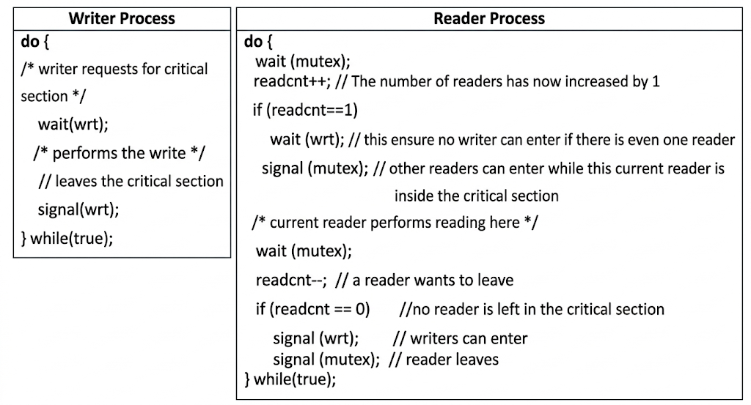
Simple C Code Example (Reader Priority)
c
#include <stdio.h>
#include <pthread.h>
#include <unistd.h>

pthread_mutex_t mutex = PTHREAD_MUTEX_INITIALIZER;
pthread_mutex_t write_lock = PTHREAD_MUTEX_INITIALIZER;
int reader_count = 0;
int shared_data = 1000; // Shared resource

void* reader(void* arg) {
int id = *(int*)arg;

for(int i = 0; i < 3; i++) {
// ENTRY SECTION: Update reader count
pthread_mutex_lock(&mutex);
reader_count++;
if(reader_count == 1) {
pthread_mutex_lock(&write_lock); // First reader locks writers out
}
pthread_mutex_unlock(&mutex);

// CRITICAL SECTION: Reading
printf("Reader %d reads: %d (active readers: %d)\n",
id, shared_data, reader_count);
sleep(1); // Simulate reading time

// EXIT SECTION: Decrease reader count
pthread_mutex_lock(&mutex);
reader_count--;
if(reader_count == 0) {
pthread_mutex_unlock(&write_lock); // Last reader allows writers
}
pthread_mutex_unlock(&mutex);

sleep(rand() % 2);
}
return NULL;
}

void* writer(void* arg) {
int id = *(int*)arg;

for(int i = 0; i < 2; i++) {
// ENTRY SECTION: Wait for exclusive access
pthread_mutex_lock(&write_lock);

// CRITICAL SECTION: Writing
shared_data += 100;
printf("Writer %d writes: %d\n", id, shared_data);
sleep(2); // Simulate writing time

// EXIT SECTION: Release access
pthread_mutex_unlock(&write_lock);

sleep(rand() % 3);
}
return NULL;
}

int main() {
pthread_t readers[3], writers[2];
int reader_ids[3] = {1, 2, 3};
int writer_ids[2] = {1, 2};

// Create threads
for(int i = 0; i < 3; i++)
pthread_create(&readers[i], NULL, reader, &reader_ids[i]);
for(int i = 0; i < 2; i++)
pthread_create(&writers[i], NULL, writer, &writer_ids[i]);

// Wait for completion
for(int i = 0; i < 3; i++)
pthread_join(readers[i], NULL);
for(int i = 0; i < 2; i++)
pthread_join(writers[i], NULL);

return 0;
}
Variations
1. First Readers-Writers Problem (Reader Priority)
- Readers don't wait unless a writer has already obtained write lock
- Can cause writer starvation
2. Second Readers-Writers Problem (Writer Priority)
- Once a writer is ready, no new readers can start
- Prevents writer starvation but can cause reader starvation
3. Third Readers-Writers Problem (Fairness)
- Uses a queue to ensure alternating access
- No starvation for either readers or writers
Real-World Examples
- Database systems: Multiple users reading, few updating
- File systems: Multiple processes reading, few writing
- Configuration management: Many readers, occasional updates
- Cache systems: Multiple reads, periodic cache updates

What is the Dining Philosophers Problem?
The Dining Philosophers problem is a classic synchronization problem conceived by Edsger Dijkstra in 1965. It illustrates the challenges of resource allocation, deadlock, and starvation in concurrent systems.
Scenario:
- Five philosophers sit around a circular table
- Each philosopher has a plate of spaghetti
- There is one fork between each pair of philosophers (5 forks total)
- Each philosopher alternates between thinking and eating
- To eat, a philosopher needs both forks (the left one and the right one)
- After eating, they put down both forks and return to thinking
Constraints:
- Forks are shared resources that must be mutually exclusive
- No two adjacent philosophers can eat simultaneously
- The solution must avoid:
  - Deadlock: All philosophers hold one fork and wait forever
  - Starvation: A philosopher never gets to eat

Visual Representation
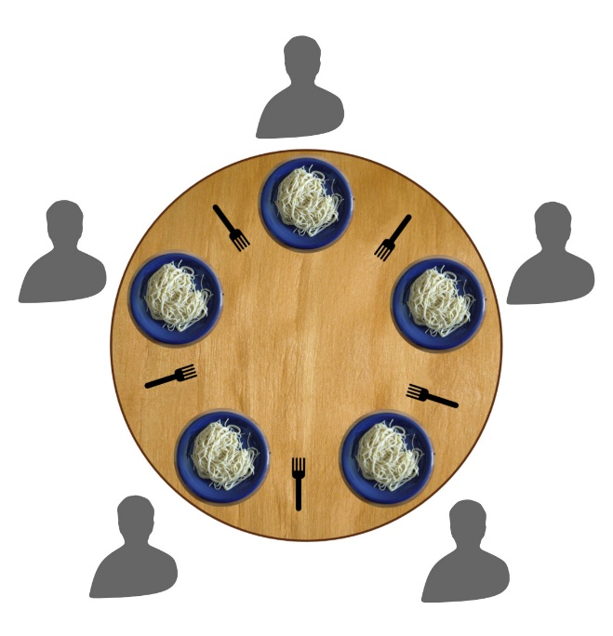

Example Scenario
Problematic Scenario (Deadlock):
- All philosophers become hungry at the same time
- Each picks up their left fork simultaneously
- Now each waits for their right fork, which is held by the neighbor
- System deadlocks — no one can eat forever

C Code --- Using Mutex Locks – Having deadlocks
#include <stdio.h>
#include <pthread.h>
#include <unistd.h>

#define NUM_PHILOSOPHERS 5

pthread_mutex_t forks[NUM_PHILOSOPHERS];
pthread_t philosophers[NUM_PHILOSOPHERS];

void* philosopher(void* num) {
int id = *(int*)num;
int left_fork = id;
int right_fork = (id + 1) % NUM_PHILOSOPHERS;

while (1) {
// Thinking
printf("Philosopher %d is thinking\n", id);
usleep(1000000);

// Pick up forks
pthread_mutex_lock(&forks[left_fork]);
printf("Philosopher %d picked up left fork %d\n", id, left_fork);

pthread_mutex_lock(&forks[right_fork]);
printf("Philosopher %d picked up right fork %d\n", id, right_fork);

// Eating
printf("Philosopher %d is eating\n", id);
usleep(1000000);

// Put down forks
pthread_mutex_unlock(&forks[right_fork]);
pthread_mutex_unlock(&forks[left_fork]);
printf("Philosopher %d finished eating\n", id);
}
return NULL;
}

int main() {
int ids[NUM_PHILOSOPHERS];

// Initialize mutexes
for (int i = 0; i < NUM_PHILOSOPHERS; i++) {
pthread_mutex_init(&forks[i], NULL);
}

// Create philosopher threads
for (int i = 0; i < NUM_PHILOSOPHERS; i++) {
ids[i] = i;
pthread_create(&philosophers[i], NULL, philosopher, &ids[i]);
}

// Wait for threads (infinite loop)
for (int i = 0; i < NUM_PHILOSOPHERS; i++) {
pthread_join(philosophers[i], NULL);
}

// Cleanup
for (int i = 0; i < NUM_PHILOSOPHERS; i++) {
pthread_mutex_destroy(&forks[i]);
}

return 0;
}

Solution 2: Deadlock Prevention (Different Fork Pickup Order)
c
#include <stdio.h>
#include <pthread.h>
#include <unistd.h>

#define NUM_PHILOSOPHERS 5

pthread_mutex_t forks[NUM_PHILOSOPHERS];
pthread_t philosophers[NUM_PHILOSOPHERS];

void* philosopher(void* num) {
int id = *(int*)num;
int first_fork, second_fork;

// Prevent deadlock: last philosopher picks up right fork first
if (id == NUM_PHILOSOPHERS - 1) {
first_fork = (id + 1) % NUM_PHILOSOPHERS; // Right fork
second_fork = id; // Left fork
} else {
first_fork = id; // Left fork
second_fork = (id + 1) % NUM_PHILOSOPHERS; // Right fork
}

while (1) {
// Thinking
printf("Philosopher %d is thinking\n", id);
usleep(1000000);

// Pick up forks in specified order
pthread_mutex_lock(&forks[first_fork]);
printf("Philosopher %d picked up fork %d\n", id, first_fork);

pthread_mutex_lock(&forks[second_fork]);
printf("Philosopher %d picked up fork %d\n", id, second_fork);

// Eating
printf("Philosopher %d is eating\n", id);
usleep(1000000);

// Put down forks
pthread_mutex_unlock(&forks[second_fork]);
pthread_mutex_unlock(&forks[first_fork]);
printf("Philosopher %d finished eating\n", id);
}
return NULL;
}

int main() {
int ids[NUM_PHILOSOPHERS];

// Initialize mutexes
for (int i = 0; i < NUM_PHILOSOPHERS; i++) {
pthread_mutex_init(&forks[i], NULL);
}
// Create philosopher threads
for (int i = 0; i < NUM_PHILOSOPHERS; i++) {
ids[i] = i;
pthread_create(&philosophers[i], NULL, philosopher, &ids[i]);
}

// Wait for threads
for (int i = 0; i < NUM_PHILOSOPHERS; i++) {
pthread_join(philosophers[i], NULL);
}
// Cleanup
for (int i = 0; i < NUM_PHILOSOPHERS; i++) {
pthread_mutex_destroy(&forks[i]);
}

return 0;
}

Monitor Solution to Dining Philosophers Problem
A monitor-based solution provides a clean, structured approach to the Dining Philosophers problem by encapsulating resource management and using condition variables to control access.

Concept Overview
A monitor is a high-level synchronization construct that provides:
- Mutual exclusion: Only one process can execute inside the monitor at a time
- Condition variables: Allow processes to wait for specific conditions and signal others
- State tracking: Maintains philosopher states (thinking, hungry, eating)
Key Idea: A philosopher can only eat when both neighbors are not eating. If forks are unavailable, they wait on a condition variable.

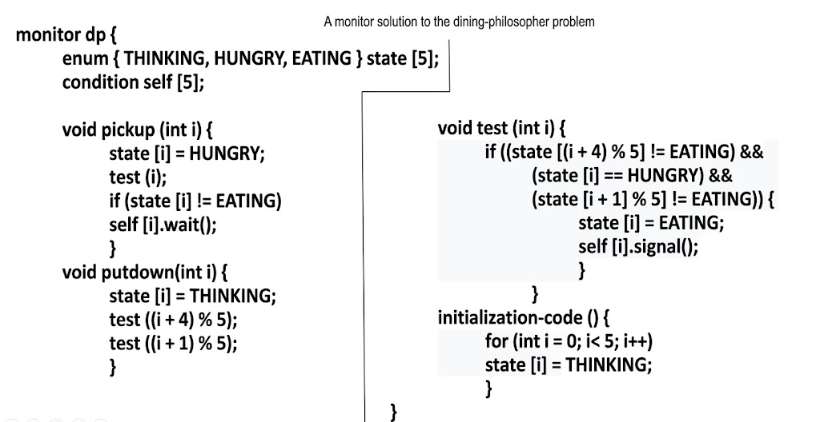

Philosopher States
c
typedef enum {
THINKING,
HUNGRY,
EATING
} PhilosopherState;
- THINKING: Philosopher is not interested in eating
- HUNGRY: Philosopher wants to eat but is waiting for forks
- EATING: Philosopher has both forks and is eating

Monitor Structure
c
#include <stdio.h>
#include <pthread.h>
#include <unistd.h>

#define NUM_PHILOSOPHERS 5

// Monitor structure
typedef struct {
PhilosopherState state[NUM_PHILOSOPHERS];
pthread_mutex_t mutex; // Monitor mutex
pthread_cond_t condition[NUM_PHILOSOPHERS]; // One CV per philosopher
} DiningMonitor;

DiningMonitor monitor;
pthread_t philosophers[NUM_PHILOSOPHERS];

Complete C Implementation
c
#include <stdio.h>
#include <pthread.h>
#include <unistd.h>
#include <stdlib.h>

#define NUM_PHILOSOPHERS 5
#define THINK_TIME 1000000
#define EAT_TIME 1000000

typedef enum {
THINKING,
HUNGRY,
EATING
} PhilosopherState;

typedef struct {
PhilosopherState state[NUM_PHILOSOPHERS];
pthread_mutex_t mutex; // Monitor mutex (for mutual exclusion)
pthread_cond_t condition[NUM_PHILOSOPHERS]; // Condition variables
} DiningMonitor;

DiningMonitor monitor;

// Function prototypes
void monitor_init();
void monitor_take_forks(int philosopher_id);
void monitor_put_forks(int philosopher_id);
void test(int philosopher_id);

void* philosopher(void* num);
int left(int philosopher_id);
int right(int philosopher_id);

// Initialize monitor
void monitor_init() {
pthread_mutex_init(&monitor.mutex, NULL);

for (int i = 0; i < NUM_PHILOSOPHERS; i++) {
monitor.state[i] = THINKING;
pthread_cond_init(&monitor.condition[i], NULL);
}
}

// Check if philosopher can start eating
void test(int philosopher_id) {
// Condition: philosopher is hungry AND neither neighbor is eating
if (monitor.state[philosopher_id] == HUNGRY &&
monitor.state[left(philosopher_id)] != EATING &&
monitor.state[right(philosopher_id)] != EATING) {

monitor.state[philosopher_id] = EATING;

// Signal that forks are now available
pthread_cond_signal(&monitor.condition[philosopher_id]);
}
}

// Philosopher attempts to pick up forks
void monitor_take_forks(int philosopher_id) {
pthread_mutex_lock(&monitor.mutex);

// Mark philosopher as hungry
monitor.state[philosopher_id] = HUNGRY;

// Try to acquire forks
test(philosopher_id);

// If not eating, wait until condition is signaled
while (monitor.state[philosopher_id] != EATING) {
pthread_cond_wait(&monitor.condition[philosopher_id],
&monitor.mutex);
}

pthread_mutex_unlock(&monitor.mutex);
}

// Philosopher puts down forks
void monitor_put_forks(int philosopher_id) {
pthread_mutex_lock(&monitor.mutex);

// Mark philosopher as thinking
monitor.state[philosopher_id] = THINKING;

// Test neighbors to see if they can now eat
test(left(philosopher_id));
test(right(philosopher_id));

pthread_mutex_unlock(&monitor.mutex);
}

// Helper functions to get neighbor indices
int left(int philosopher_id) {
return (philosopher_id + NUM_PHILOSOPHERS - 1) % NUM_PHILOSOPHERS;
}

int right(int philosopher_id) {
return (philosopher_id + 1) % NUM_PHILOSOPHERS;
}

// Philosopher thread function
void* philosopher(void* num) {
int id = *(int*)num;

while (1) {
// Thinking
printf("Philosopher %d is THINKING\n", id);
usleep(THINK_TIME);

// Get hungry and pick up forks
printf("Philosopher %d is HUNGRY\n", id);
monitor_take_forks(id);

// Eating
printf("Philosopher %d is EATING\n", id);
usleep(EAT_TIME);

// Put down forks
printf("Philosopher %d finished EATING\n", id);
monitor_put_forks(id);
}

return NULL;
}

int main() {
int ids[NUM_PHILOSOPHERS];

// Initialize monitor
monitor_init();

// Create philosopher threads
for (int i = 0; i < NUM_PHILOSOPHERS; i++) {
ids[i] = i;
pthread_create(&philosophers[i], NULL, philosopher, &ids[i]);
}

// Wait for threads (infinite)
for (int i = 0; i < NUM_PHILOSOPHERS; i++) {
pthread_join(philosophers[i], NULL);
}

return 0;
}

